RETURO SISTEM GARANŢIE RETURNARE S.A.

Request for Proposals (RFP)

Lifting equipment for the
SGR System operations

Date of Issue: 28.10.2025

Address: Globalworth Campus, str. Ing. George Constantinescu nr. 4B și str. George Constantinescu nr. 2-4, clădirea A, etaj 4, Sector 2, București, România

Table of Contents

1. Summary and Background 3
2. Proposal Guidelines……………………………………………………………………………………….4
3. Project Purpose and Description ………………………………………………………………….…4
4. Project Scope……………………………………………………………………………………………….7
5. Request for Quotation and Project Timeframe…………………………………………………8
6. proposal evaluation criteria 8

Summary and Background

The implementation in Romania of the deposit-return system for non-reusable primary packaging is regulated by Law no. 249/2015 regarding the management of packaging and packaging waste, with subsequent amendments and additions, and by Government Decision no. 1074/2021 regarding the establishment of the deposit-return system for non-reusable primary packaging, as well as other relevant normative acts.
RETURO SISTEM GARANTIE RETURNARE SA, herein named RetuRO SGR, appointed as the administrator of the Deposit-Return System (SGR) under Government Decision no. 1.059/2022 regarding the appointment of the administrator of the deposit-return system, for non-reusable primary packaging and, in this sense, has implemented, and is managing and operating the system.
Our Business Model considers multiple participants and complex connections between them and the administrator of SGR:
- Producers and Importers who introduce packaged products on the national market.
- Traders are already established or are starting to sell products in packaging that are subject to SGR.
- Consumers buying products in packaging that are subject to SGR.
- The Suppliers that ensure the specialized equipment for the established return points (Reverse Vending Machines – RVMs).
- Transportation companies.
- Suppliers of the equipment from RETURO logistics/operational sites, where SGR products are counted, sorted, and prepared for being redirected to recycling companies.
- Recycling companies.

The purpose of this tender is to provide us with the necessary lifting devices and background services to ensure our seamless and smooth operational capabilities.

Proposal Guidelines

This Request for Proposal represents the requirements for an open and competitive process. Proposals will be accepted until November 21st, 2025.
Any proposals received after this date (date of e-mail receipt) will not be considered. All proposals must be signed by an official agent or representative of the company submitting the proposal.

Project Purpose and Description

The purpose of this project is as follows:
RetuRO SGR is responsible for operating several national processing centers, which are performing the following main activities:
- Reception of collected packaging.
- Counting of collected packaging.
- Sorting of collected packaging, by material type and color (where applicable)
- Baling of sorted material
- Selling the sorting material to recyclers and customers
The types of materials that RetuRO processes are PET, non-ferrous metals, and glass. RetuRO SGR collects the packaging from the retailers, via two main directions:
- Manual collection
- Automated collection, through Reverse Vending Machines or RVMs

Project Overview:
Our company is seeking three types of new lifting equipment for rental, to support our logistics operations. We welcome proposals from your company, including rental & acquisition solutions for the required equipment.

Technical Specifications:
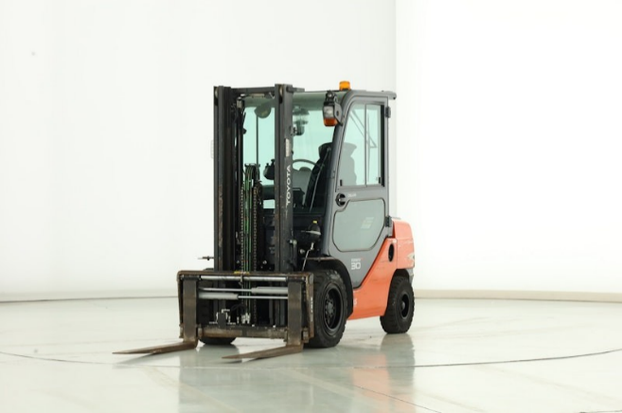
- Lifting equipment with forks & clamps

- Capacity: load carrying capacity 2T
- Usage – interior/exterior (roof & doors superstructure needed)
- Lift Height: height to which the forklift can lift the load – 6m
- Fuel Type: electric (expected storage: ideally Li-I batteries) acc to Table 1
Fig. 1
- Forecasted usage/year (2-4000h), depending on the volumes, might increase (consider a flexible offer to consider extra time).
- Fire suppression equipment included.
- Independent forklifts with forks and with clamps requested in all the locations. (Fig 1 and Fig 2)
- Extra acc. – to ensure full usage with a fast battery swapping and charging system to exchange discharged batteries with fully charged ones quickly. (acc. Table 1)
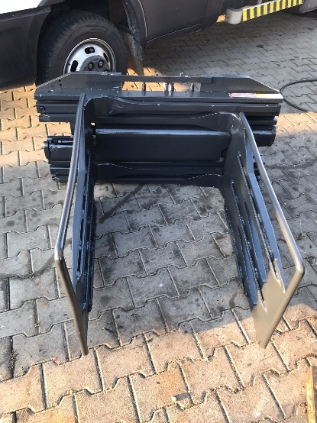
- Tire type – mixt (interior/exterior),
- Free lifting height – 2m
- Fork length – 1.2m
- ASL for any issues & service– 4h
- ASL for replacement forklift – 24h
- Having a ‘Live Link’ or similar, for external tracking, monitoring & reporting, would be a great plus

Forklift safety requests:
- A pedestrian detection AI camera system, front and rear, would be a great plus.
- Blue Spot LED Lamp front and rear.
- Low Height LED Flashing Beacon.
- Panoramic Rear View Mirror.
Fig. 2
- Full LED Light Package.
- High-visibility seat belt.
- Acoustic signal during reversing 110 db.
- FOPS.

2. Forklift with box rotator attachment (Fig.3)

- Usage – interior/exterior
- Fire suppression equipment included.
- Having a ‘Live Link’ or similar, for external tracking, monitoring & reporting, would be a great plus
- Lifting height 6 m
- Lifting capability: 1,5 -2 tons

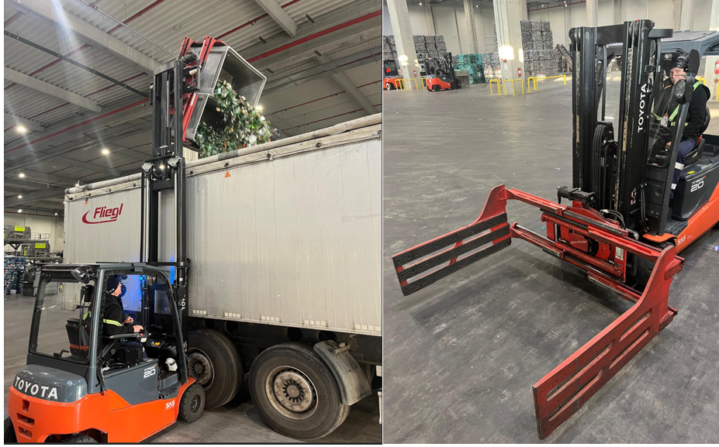
Fig. 3

3.Manual pallet truck (Fig. 4)
Fig. 4
- Usage – interior/exterior (PU wheels for smooth concrete floor)
- Euro pallet size
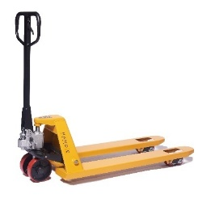
- Minimum 2 pcs/each location

All solutions need to be:
- Environmental Protection: there may be protective measures in place to safeguard against environmental factors such as moisture, dust, and temperature variations.
- Compliance: to meet relevant industry standards and regulations regarding weighing equipment, ensuring accuracy, functionality, and reliability in accordance with legal obligations (ISCIR).
- All equipment should allow 24-hour continuous usage in extreme summer/winter environmental conditions.
- The supplier must hold valid ISCIR authorization; failure to provide this will result in disqualification from the tender.

PROJECT SCOPE

We are kindly asking you to provide a quotation & deployment plan for each product mentioned in the locations from table 1.
- Lifting equipment with clamps, white int. wheels: 4 pcs
- Lifting equipment with clamps, black int. wheels: 16 pcs
- Lifting equipment with forks Li-Ion battery, white int. wheels: 2 pcs
- Lifting equipment with forks Li-Ion battery, black int. wheels: 7 pcs
- Lifting equipment with turning, interior +exterior wheels: 10 pcs
- Spare batteries, total: 20 pcs with tolerance of 8pcs
- Manual pallet truck: 18 pcs

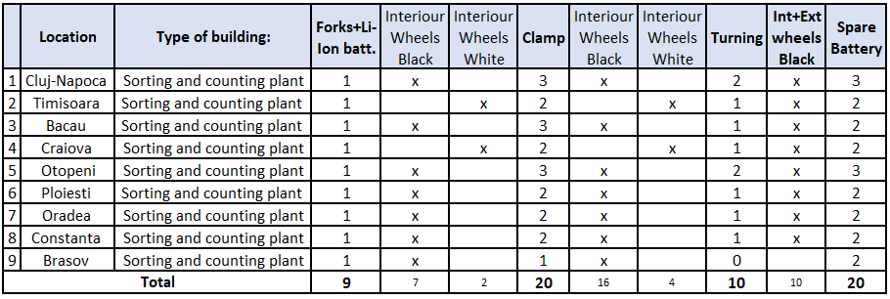

Extra Requirements to be considered:
- Please provide a price for snow plough accessories that can be added to the forklift.
- Please provide the price for the fork extension accessory.
- Spare part list price and detailed costs for extra technical services that are not included in the basic package.
- Spare parts list available in the supplier’s stock (all parts that require more than 48h delivery should be available in the supplier’s stock).
The plant locations are as follows, along with the required number and type of lifters and spare batteries, as shown in Table 1.

Request for Proposal Content and Project Timeline

All bids shall reach us no later than until November 21st, 2025, and shall contain:
- Company presentation.
- Brief and clear technical presentation of the devices.
- Timetable to take over the project.
- Minimum one recommendation from a relevant customer, with the option to
check.
- Financial proposal for a 2-year program lifetime.
- Other details proposed

Preliminary Evaluation and Selection (Eligibility + Commercial Analysis) will be done by December 12, 2026.
Contract signing is expected by: March 2026.

Proposal Evaluation Criteria

The proposals will be evaluated based on the following criteria:
- Technical specifications and compatibility with our requirements
- Local technical team availability and minimum time needed for critical interventions.
- Implementation plan and timeline
- Maintenance and support ASL
- Pricing competitiveness
- Financial Risk

We reserve the right to request additional information or clarification during the evaluation process. Please note that this RFP does not guarantee the award of a contract. All costs associated with the preparation and submission of the proposal shall be the vendor's sole responsibility.
Thus, please do not use any other means of communication and do not directly contact directors or other Internal employees of RetuRO, members of Board of Director’s, members of the Supervisory Board, regarding this tender. Please address all your communication/additional requests directly to achizitii.cos3@returosgr.ro
Repeated or severe violations of this communication rule may lead to the exclusion of the bidder.

If you have any questions or require further information, please contact achizitii.cos3@returosgr.ro

We look forward to receiving your proposal and potentially working with you to fulfill our weighing solution requirements.

